Unity Tutorial: AI Patrol System

1. Create a scene

Set up the scene with a character on top of a platform with a 2D box collider for the platform.

1. Creating a C# script

Add this code above the page which will set up the character to walk across the platform and preventing it to not walk off the platform. Then go back to Unity, create an empty object named Ground Detection with a small gizmo and place it on the bottom right side of the character and must be near it so it can detect it with the script enabled. Also, make sure it is a child under the character.

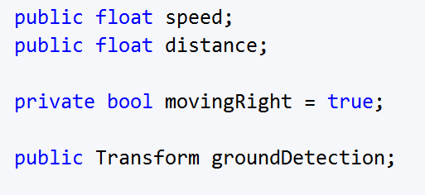

1. Adding the variables

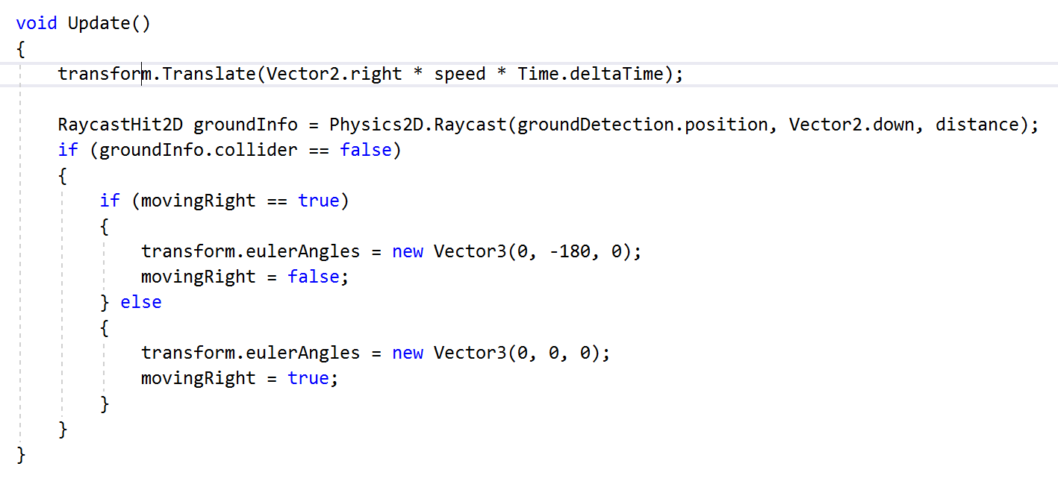Add this code below which makes the character have a calculated connected to the ground detention and once it's in place, drag the transform to the patrol section in the character and now the character should be moving both rights to left-back and forth.